**ICOMOS Aotearoa New Zealand NEWS

Te kawerongo hiko ō te mana ō nga pouwhenua ō te ao

SEPTEMBER 2024 ISSN 0113-2237 [[www.icomos.org.nz](http://www.icomos.org.nz)](http://www.icomos.org.nz)

Some of the nearly one million artefact fragments found in Christchurch after the earthquakes of 2010 and 2011

**Christchurch Archaeology Project**

**Dr Katharine Watson**

Archaeological data. What do we do with it all? In Aotearoa, such data is typically recovered as a result of the archaeological authority process administered by Heritage New Zealand Pouhere Taonga (HNZPT).

Archaeological sites are protected by legislation because they’re a public good – a significant and irreplaceable source of information about our past. So not only does the legislation protect archaeological sites, it facilitates the recovery of information from sites that are going to be damaged or modified.

It does not, however, protect the data recovered and nor does it fully protect the material recovered. While the results of archaeological investigations are made available through archaeological reports, these aren’t particularly accessible to the general public and are, necessarily, site specific. They don’t synthesise data, they don’t generally seek to answer big picture questions and the data contained in them is essentially locked in a pdf.

Such synthesis and analysis are required to truly realise the public good of archaeological investigations. [Christchurch Archaeology Project](https://www.christchurcharchaeology.org/) was born out of these concerns, specifically as they relate to Ōtautahi Christchurch and the quantities of archaeological data generated as a result of the Canterbury earthquakes of 2010 and 2011.

The volume of archaeological work during this period was unprecedented, with almost 4000 earthquake archaeological authorities issued and close to a million artefact fragments recovered. The resulting archaeological archive (that is, the physical materials recovered from archaeological sites and the associated archaeological and historical data) is a unique window into Canterbury’s past, with the potential to provide significant insights into Christchurch’s story. But the form of the archive, scattered across disparate physical and digital locations, made this nigh on impossible.

To solve this problem, to make the data accessible and to enable a whole range of people to explore Ōtautahi’s past, we established the [Museum of Archaeology Ōtautahi (MoAŌ)](https://museumofarchaeology.org/).

|  |  |
| --- | --- |
| **In this issue:** |  |
| **President’s report** | **3** |
| **From the Board** | **4** |
| **Our members** | **6** |
| **Publications** | **10** |
| **Scholarships, grants and jobs** | **11** |
| **Training and events** | **12** |

MoAŌ is an online database of archaeological material, providing access to archaeological data through two interfaces. We think of these as a public interface and a researcher interface, but the reality is that both are freely available to all, although the researcher interface requires users to sign up and have login details.

The public interface contains a curated subset of the data, including basic information about archaeological sites (the location, the site type, the period of occupation), archaeological features (again, type and period of use) and artefacts.

There’s also historical information about the people and organisations associated with each site and/or feature, and it’s possible to follow the connections between these people, organisations and places. We’ve tried to make this data as user-friendly and image-rich as possible, to ensure that it’s engaging, and to facilitate artefact identification. The public interface is searchable using a range of categories but there is, as yet, no map to facilitate searching.

The [researcher interface](https://researchdata.museumofarchaeology.org/) presents all of the data, essentially in a warts-and-all fashion. This data is drawn directly from the spreadsheets used to upload the data to MoAŌ. It includes everything from the archaeological authority number, when the archaeological work took place, the dimensions of each feature, the site’s stratigraphy and all of the nitty-gritty details of the artefact analysis. There are no images in the researcher interface. The data is presented in spreadsheet format and can be filtered and exported. The latter functionality allows the researcher to manipulate and analyse the data for their own purposes.

MoAŌ is still very much a work in progress. To date, we have entered data from 356 projects. This encompasses 470 archaeological sites, 2,345 people and over 19,000 artefacts. There’s still a lot more to go. Further, this data only relates to European archaeological sites, and only those sites with below ground archaeology.

Consultation with the relevant Ngāi Tahu papatipu rūnanga is required before data from sites of interest to Māori can be entered, and this is about to get underway. Work to enter the first buildings archaeology is also in progress. In addition, the historical data in MoAŌ is in many ways incomplete: all the data currently in MoAŌ was extracted from final reports, with no additional research or analysis undertaken. As such, the information in MoAŌ about any given individual is only that which was in the report. Often, this is little more than a name. Nor are there images for all artefacts or sites.

Finally, in terms of data entry, work is underway with Underground Overground Archaeology to establish a process whereby they enter data into MoAŌ as reports and projects are completed. Not only is there more data entry to be done, the website itself requires enhancements and refinements (including the aforementioned map). So, yes, more funding is required…

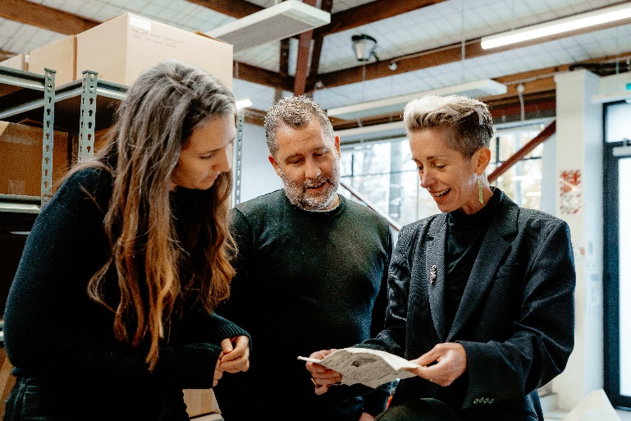The initial database build, construction and data entry was funded by a grant from Manatū Taonga Ministry for Culture and Heritage. The database and website were built by local Christchurch firm Intranel and the database was designed by Great Scott, another Christchurch business. The data entry was carried out by our data entry team of **Ebony Pike, Madison Gamble, Sam Wallis** and **Sayali Sangamnerkar.** We’re very grateful for the generous support and tireless efforts of these people and organisations, without whom establishing MoAŌ would not have been possible.

Dr Watson (right) and MoAŌ collaborators

President’s report

Kia ora koutou

Stacy Vallis, ICOMOS Aotearoa New Zealand President

As we are now well into the second half of 2024, our national committee and the international ICOMOS community are looking forward to the annual opportunities to meet, reflect, and discuss all things heritage at the upcoming ICOMOS Aotearoa New Zealand Annual Conference and AGM taking place 18 – 20 October 2024 in Ōtepoti Dunedin, along with the ICOMOS International Annual General Assembly and Scientific Symposium scheduled for 10 – 17 November in Ouro Preto, Brazil.

Our national conference programme and call for papers has recently been circulated and we’re excited to announce the theme of ‘Everyone’s Heritage’ featuring our shared cultural heritage, drawing on local experiences and heritage values from our Aotearoa New Zealand context. Examining the complexity of heritage values is especially relevant as we continue to navigate rapid change. A stimulating programme including field-trips and invited speakers awaits!

Accompanying these national discussions, the [ICOMOS International Scientific Symposium in Brazil](https://www.icomos.org/en/pub/690-english-categories/about-icomos/governance/general-%20assembly/ga2024/140928-aga2024-annual-general-assembly-and-scientific-symposium-ouro-preto-%20brazil) will take a global lens to the evolution of cultural heritage conservation perspectives. There will be a specific focus on the 60th anniversary of the Venice Charter and its application to current heritage practices, contemporary challenges such as climate change, social inequalities, and the need for adaptive heritage conservation practices.

In case you haven’t already had a chance, the [2023 ICOMOS Annual Report](https://www.icomos.org/en/about-icomos/2016-11-17-13-14-08/annual-reports/141590-%20rapport-annuel-2023-de-l-icomos-2) is also available to check out. There’s a great summary of the initiatives that ICOMOS is leading to address issues concerning heritage education, digitalisation, climate change – plus links to publications and resources produced across the international ICOMOS network and its partners.

I hope to see you in Ōtepoti Dunedin!

Kia Kaha Aotearoa.

|  |
| --- |
|  |

**From the Board**

|  |
| --- |
|  |

Heritage and resource management

Heritage and character area protection have recently been a topic of discussion at the ICOMOS Aotearoa New Zealand Board table because of District Plan changes in Christchurch, Hutt City and Wellington.

In Christchurch, the Council is asking the Government for more time to complete parts of its decision-making on Plan Change 14 while it seeks clarity about recommendations from the Independent Hearings Panel (IHP). The IHP has recommended removal of several items from the plan’s heritage schedule including the [Blue Cottage](https://www.thepress.co.nz/home-property/350402130/historic-blue-cottage-chopping-block) and [St James Church](https://www.thepress.co.nz/nz-news/350363721/heritage-listed-st-james-church-one-step-closer-wrecking-ball).

In Hutt City, local advocacy organisation the [Voluntary Heritage Group](https://voluntaryheritage.wordpress.com/) says that heritage rules are too tight and that heritage protection should require owner consent.

In Wellington, the recent review of the District Plan resulted in 75% of character area protections being removed. The IHP also recommended changes to the heritage schedule. The Council objected to 10 of the places that the IHP recommended were added or retained on the schedule including Gordon Wilson Flats (featured on the cover of the June 2024 ICOMOS Aotearoa New Zealand newsletter) and the Miramar Installation Bulk Storage Tank.

The Council asked **Hon Chris Bishop** (the final decision-maker on the plan change) to remove them from the schedule. Minister Bishop ultimately decided (reluctantly it seems) that they should be retained due to a lack of evidence for removing them.

Wellington City Council is unhappy with the outcome of the plan review. In March 2024, Wellington **Mayor Tory Whanau** wrote to Minister Bishop asking for a law change to make it possible to remove heritage buildings from plan schedules via a simple Council decision (i.e. without the usual Resource Management Act (RMA) process).



Hon Chris Bishop, Minister Responsible for RMA Reform and Tory Whanau, Mayor of Wellington

Since then Minister Bishop has spoken publicly about his plans for heritage in RMA reform. For example, in his recent [speech to the Local Government New Zealand conference](https://www.beehive.govt.nz/speech/speech-local-government-new-zealand-conference) where he said:

We are also looking at changing the way we manage heritage in this package of reform. Managing heritage listed buildings is a significant issue for building owners and councils, as highlighted earlier this year when Wellington City Council tried to delist the Gordon Wilson Flats and other heritage buildings.

The continued existence of Gordon Wilson Flats is an ugly scar on the Wellington skyline. The property owners want it gone. The community want it gone. Even the council want it gone. But still it stands – held up only by crumbling walls and a crumbling heritage system that values the preservation of falling-down eyesores over growth and modernity.

At our May 2024 meeting the ICOMOS Aotearoa New Zealand Board agreed to write to Minister Bishop and **Hon Paul Goldsmith**, Minister for Arts, Culture and Heritage about the recent ministerial and media interest in the heritage protection system. Our letter includes an offer to meet with them to discuss the management of heritage. The Board looks forward to hearing back from Ministers and continues to monitor the situation.

ICOMOS New Zealand Travel Scholarship

The Board has awarded **Alex Vakrousheva** an ICOMOS New Zealand Travel Scholarship. Alex is also the 2024 recipient of the [Greg Bowron Memorial Trust Scholarship](https://www.hthub.ac.nz/greg-bowron-trust/).

Together these scholarships will allow Alex to return to Tasmania in 2025 and complete the second installment of the Longford Academy Conservation School.

An international standard for heritage conservation

Standards New Zealand/MBIE is coordinating the national membership to the International Organization for Standardization (ISO) Technical Committee where ICOMOS Aotearoa New Zealand will participate alongside the Department of Conservation, New Zealand Conservators of Cultural Materials, Museums Aotearoa, and other conservation organisations.

As a participating member, New Zealand has the right and obligation to vote on all documents and attend international meetings whenever possible. ISO is an independent, international, non-governmental organisation dedicated to the development of international standards on various technical matters.

The scope of ISO Technical Committee on Cultural Heritage Conservation (ISO/TC 349) is standardisation in the field of terminology, technologies, materials and equipment for monitoring, evaluation, preservation, and restoration of tangible cultural heritage.

The establishment of ISO/TC 349 is anticipated to make significant contributions to the conservation of cultural heritage by fostering consensus and research as well as elevating the standard of cultural heritage conservation internationally. ISO/TC 349 will develop, but not be limited to, the following international standards for conservation of cultural heritage in the first three years:

1. Terminology
2. Deterioration and illustration
3. Restoration techniques for inorganic porous cultural relics (stone, wall painting, earthen sites)
4. Specification for seismic protection of museum collections
5. Environmental monitoring for museum collections.

Committee members undertake their involvement on a voluntary basis in exchange for benefits such as having the opportunity to shape the future development of a standard, gain a greater understanding of sector and industry trends (both nationally and internationally), network with fellow experts from industry and business and work with peers internationally to shape international best practice.

Approved members of ICOMOS Aotearoa New Zealand will represent our organisation on the national mirror committee of the ISO TC/349. These members will be the point of contact for this initiative for ICOMOS Aotearoa New Zealand and will form a working group within our Legislation & Policy Committee. 

|  |
| --- |
|  |

**Our members**

|  |
| --- |
|  |

Getty Conservation Guest Scholarship awarded

**Kararaina Te Ira**

Tēnā koutou. He uri au o ngā tūpuna mai ngā waka ō Tokomaru, Kurahaupō, Tainui, me Takitimu. Ko Kararaina Parerohi Rāhui Te Ira taku ingoa.

My name is Kararaina Te Ira and some of my iwi (tribal affiliations) are to Ngāti Raukawa, Ngāti Tūwharetoa, Ngāti Hinemihi, Ngāti Kahungunu, Ngāti Apa ki te Rā To, Ngāti Kuia and Rangitāne o Wairau.

In 2025 I will be a guest scholar for the 2024/2025 intake at the Getty Conservation Institute for three months. As a guest scholar, I will be pursuing a project that has been in my mind for the last ten years: A Practitioner's Experience: Advancing Cultural Heritage Conservation through the Eyes of Indigenous Communities. My research focuses on advancing cultural heritage conservation through the lens of Indigenous peoples’ perspectives, particularly my own Indigenous background as tāngata whenua ki Aotearoa.

The project sets its sights on what future opportunities there are that can enhance conservation practice. At the institute and the wider Center, I will grasp an understanding of how the Center operates and what their aspirations are going forward into the future. From there I will be able to gauge where the opportunities are for both organisations like the Getty Center and indigenous peoples to co-develop in line with their corresponding aspirations and goals. It is important for me to ground this project within my own whakapapa (ancestry) as an indigenous person of Aotearoa-New Zealand. From there the opportunities and alignment will be more evident as a starting block for other indigenous groups and communities.

It is a great honour to be selected as a Getty guest scholar as both Māori and a New Zealander. From looking at the list of past scholars, the last obvious New Zealander to be selected was over a decade ago. When I look at the current political space in New Zealand, post COVID-19 realities, and where Māori are collectively and economically, many changes have occurred.  Although in some cases this has been slight, changes of perspectives in New Zealand have diversified since and particularly when considering the preservation of heritage. These shifts have naturally realised both challenges and opportunities.

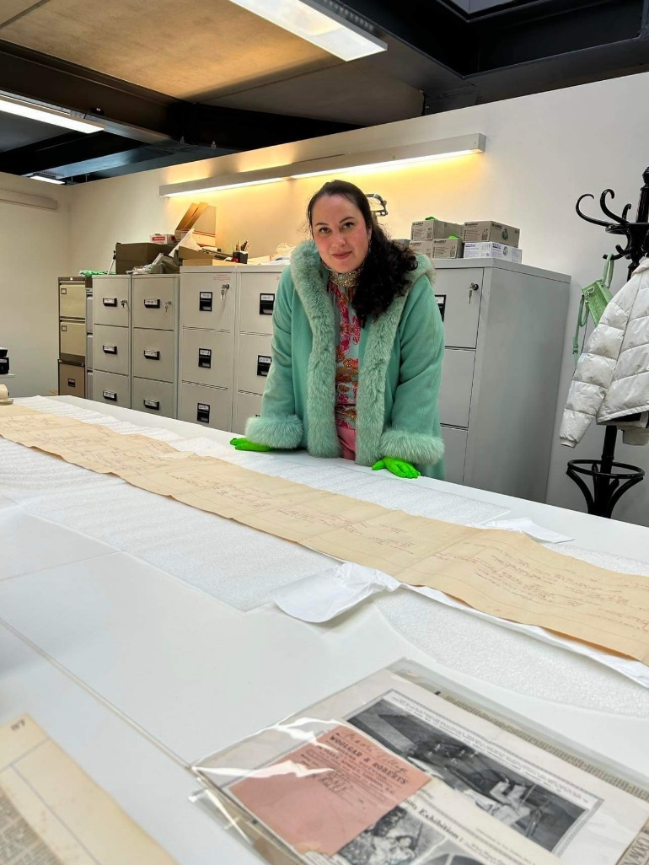

Kararaina at work

My background in heritage started from an early age as I was raised with my grandparents, aunts and uncles and parents. As my grandparents moved seasonally, we lived in our various papakāinga (ancestral homes) throughout the year. This is a privilege that many of my kin have limited access to as many Māori had left to work in the cities decades ago. With that privilege, my primary education was focussed on Māori cultural heritage, our histories, our shared stories with the wider community and taonga. When visiting family in the cities we attended hui at local galleries, museums, libraries and archives. We knew these places as visitors but much of the operation, particularly the decision-making, was kept hidden away.

At home, heritage organisations were spoken about as the keepers of the collective consciousness, and with that power, they had the ability to erase or augment our stories. If it wasn’t for a small handful of Māori heritage professionals and GLAM sector sympathisers these places were viewed as domineering entities that sought to control our cultural identity. Unlike some papakāinga, mine taught me to see past the oppression and instead seek and realise the opportunities. We knew we could keep our own memories alive and well without these organisations, but they had a role and we had a role to ensure that the taonga and our stories within their walls were cared for. This is what my whānau continues to do today, we collaborate with these organisations to penapena (care for) our taonga and stories captured there.

For over ten years I have worked as a benchtop conservator, field conservator, art and social history curator, collections curator, museum director, heritage specialist in government and recently as a senior leader in an archive. It has been my goal to work across many types of organisations in the sector and in different roles to gain insight and know the business inside and out.

During the last five years, separate to my primary work, I have been researching and writing briefs of evidence about the harm caused by the Crown/New Zealand Government against my iwi. Knowing how heritage organisations work has enabled me to utilise the information they hold to add to these briefs of evidence. The intent and focus of these briefs are primarily on the challenges caused by Government that continually disempower my kin. Very rarely have I had the opportunity to research and write about how our understanding of our past and present informs possibilities for the future.

When I was encouraged to apply for the Getty scholarship in 2021, I knew it was an opportunity to write about the possibilities for Māori and other indigenous peoples to ultimately enhance the heritage sector and align all our aspirations. This type of opportunity is rare when you work in a nine-to-five job and are constantly called to contribute to iwi matters, and especially with a world leading heritage organisation.

My main aspiration is to highlight the opportunities for co-development in enhancing the conservation practice and potentially reimagine the practice as something more fluid going forward into the future.

If you are interested in applying to be a Getty Guest Scholar, I recommend that you propose a project that resonates with you. My project is collective-minded and focusses on opportunities for today and tomorrow’s people. If your first attempt doesn’t connect with the Getty, then request feedback and try again. 

Applications for the next intake of Getty Conservation Guest Scholars are open from now until 1 October 2024

(see Training and Events section for more)

More Architecture Awards for members…

In the June 2024 newsletter, we reported on ICOMOS Aotearoa New Zealand members who received gongs at the recent NZIA awards. We neglected to mention the following - a significant achievement for Hastings District Council.

**Hawkes Bay/Gisborne heritage category**

Matthews & Matthews Architects Ltd for [Toitoi Municipal Building in Hastings](https://www.nzia.co.nz/awards/local/award-detail/11733). 

Membership cards

Paid-up members for 2024 should have received their cards in the post. Visit [www.icomos.org](http://www.icomos.org) to download your digital card. 

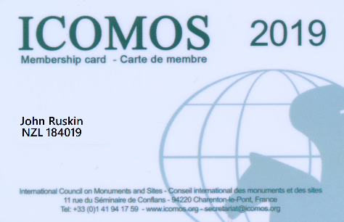

Heritage Conservation at Unitec School of Architecture  
Unitec Te Whare Wānanga o Wairaka – Te Pūkenga

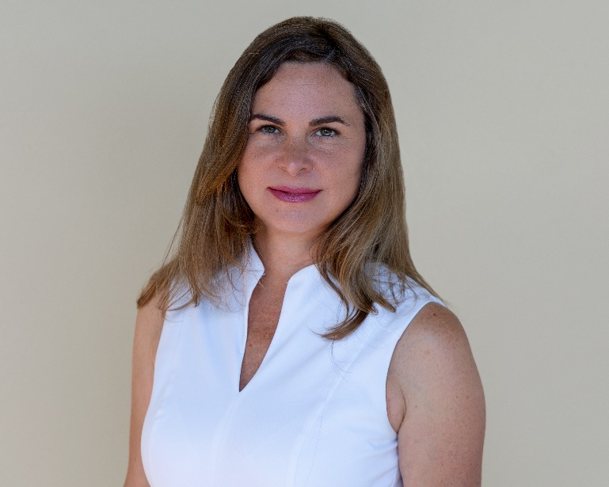

Renata Jadresin-Milic, Associate Professor and Discipline Leader at School of Architecture at Unitec

**Renata Jadresin-Milic**

Unitec School of Architecture is dedicated to embedding heritage topics and key learnings about heritage conservation throughout the Bachelor of Architectural Studies (BAS) and Master of Architecture (Professional) (MARCP) curricula.

Rather than relegating these crucial subjects to specialised programs offered later in the academic journey, we integrate them across all strands of our curriculum. This approach is actively implemented in the Critical Studies, Architectural Technology, and Design Studio strands of both BAS and MARCP.

By weaving heritage conservation into our educational framework, we aim to foster a deeper interest in tangible and intangible heritage among our students and ensure they are well-prepared to contribute to the preservation of our cultural heritage after graduation.

Unitec provides final year Master students with the opportunity to complete their Master thesis (120 credits) within the Conservation and Heritage Research Group. The group is dedicated to design-led research, engaging design and its methodology as research, with an approach to building conservation that recognises the value of utilising various conservation methods in accordance with the ICOMOS New Zealand Charter, based on a detailed investigative analysis of the varied layers of embodied history.

Some of the Master thesis topics include:

* A Layered Conservation Response to the Layers of Built History: The Canterbury Provincial Government Buildings
* The place of adaptive reuse in revitalising a historic church: St. David’s Presbyterian Church in Auckland
* Saving St James: Adaptive reuse of abandoned St James Church in Mt Eden
* Cementing a Future: Wilson’s Cement Works at Warkworth
* Functional Heritage: Mornington cable car line Dunedin
* yātra: redefining pilgrimage: Enhancing cultural heritage at Rāmappa Temple.

**Elective Courses in Heritage Conservation**

**ARCH8629 Building Conservation**

This Level 8 elective in Unitec’s MARCP programme, introduced in 2016, aims to cultivate a critical understanding of the history, theory, and practice of building conservation in Aotearoa New Zealand. The course covers the history of heritage protection and building conservation practices both internationally and within Aotearoa New Zealand, emphasising heritage as a source of cultural identity and valued memory. Students learn to assess heritage values and determine appropriate conservation strategies and degrees of intervention, guided by the ICOMOS New Zealand Charter, with a particular focus on

adaptive reuse. Guest presenters, including heritage professionals from HNZPT, Archifact, Salmond Reed, and Cheshire Architects, enrich the learning experience and ensure students are well-equipped to engage with and contribute to the field of building conservation.

**ARCH8628 Re-designing Earthquake-prone Buildings**

This Level 8 elective in Unitec’s Master of Architecture (Professional) programme, introduced in 2014, delves into the contemporary challenges faced by earthquake-prone buildings in Aotearoa New Zealand. Students critically examine the

Unitec Digital Heritage Research Centre documentation of the Old Carrington Hospital

legislation governing the structural upgrade of earthquake-prone buildings and its implications for many heritage buildings. They analyse how this legislation affects specific building typologies and document the plans and constructional details necessary to achieve structural upgrades and design initiatives.

**ARCH7624 Special Topic 3 – Digitalisation of Heritage**

This Level 7 elective focuses on the integration of digital technologies in heritage projects and academic research. This 15-credit course provides both practical and theoretical modules on digital and analogue surveys of heritage buildings. Students

engage in hands-on experiences, including 3D scanning, data processing, and modeling, on real-world examples guided by industry experts. Students gain knowledge about digital tools, equipment, and software used by architects today. The key skills developed ensure students are well-prepared to apply digital technologies in the preservation and study of architectural heritage.

**ARCH7611 and ARCH8611 Negotiated Studies**

Building further on the above skills, these courses provide students with the opportunity to engage with international perspectives on conservation issues, work on international projects, and collaborate with professionals concerned with heritage conservation problems. Examples include the international program [Cultural Landscape and Heritage Skills in Lizori, Italy](https://disegnarecon.univaq.it/ojs/index.php/disegnarecon/article/view/619), held in June 2018, and the most recent Samoa Project in 2024.

**Digital Heritage Research Centre**

In 2022, Unitec established the Digital Heritage Research Centre. The centre aims to enhance education and the use of modern digital technologies for the preventive protection and documentation of heritage buildings and sites in Aotearoa New Zealand.

It operates in a transdisciplinary manner and includes national and international collaborations. BAS and MARCP students actively participate in research projects. Some of the recent projects include [Old Carrington Hospital](https://www.mdpi.com/2071-1050/14/24/16432) (above) and the [Colonial Ammunition Company Shot Tower](https://disegnarecon.univaq.it/ojs/index.php/disegnarecon/article/view/1236) (featured in the March 2024 newsletter).

|  |
| --- |
|  |

**Publications**

|  |
| --- |
|  |

**I**[**nventories and Surveys for Heritage Management: Lessons for the Digital Age**](https://www.getty.edu/publications/inventories-and-surveys/)

A new free online publication from the Getty Conservation Institute by **David Myers** and **Janet Hansen** is now available: ‘[Inventories and Surveys for Heritage Management: Lessons for the Digital Age](https://www.getty.edu/publications/inventories-and-surveys/)’. This open-access publication provides essential guidance on digital inventories and surveys for the identification, conservation, and management of heritage places.

It draws from the Getty Conservation Institute’s ongoing work with heritage inventories over more than two decades, including through the Arches Project, on the Los Angeles Office of Historic Resources’ experience with SurveyLA (the citywide cultural resource survey of Los Angeles) as well as from the experience of other international contributors. It provides technical advice, guidance, and lessons learned for employing inventories and surveys as tools for heritage conservation and management.

This publication will be a useful resource to heritage organisations and practitioners as well as educators and students. Information about accessing a free electronic version (including PDF and EPUB formats) as well as purchasing print copies of this publication is [online](https://www.getty.edu/publications/inventories-and-surveys/).

**New heritage, energy and sustainability publications**

Two reports recently released in Australia are both important contributions to the heritage, energy and sustainability field:

* [Passive House (Passivhaus) as applied to heritage buildings](https://www.issinstitute.org.au/_files/ugd/51e950_1f6729fbcb18454ea2ec2794f637c01e.pdf), George Alexander Foundation Fellowship Report 2024, by **Ruth Redden**
* [Sustainable heritage buildings guide](https://www.environment.nsw.gov.au/research-and-publications/publications-search/sustainable-heritage-buildings-guide), **Steven Barry**, and the project team at Transport NSW and Heritage NSW. 

**Historic Places Aotearoa newsletter**

[HPA’s September newsletter](https://historicplacesaotearoa.nz/images/oculus/vohsep24lowres.pdf) is out now with articles on:

* Palmy heritage alive and well
* Heritage delisting
* Earthquake Prone Buildings Review
* and much more…

Save the Chateau Tongariro Hotel petition

**Mayor Weston Kirton** has established [a petition](https://petitions.parliament.nz/c9ffd862-08cd-46a0-5a8d-08dc72d04919) on behalf of Ruapehu District Council:

*That the House of Representatives urge the Government to act quickly to save the Chateau Tongariro Hotel, restoring it to its former glory, serving as a vital centrepiece of cultural heritage, economic prosperity, and tourism excellence in the Ruapehu District and throughout New Zealand.*

Signatures are now being accepted (at last count there were over 11,000) and the closing date is 30 November 2024. 

|  |
| --- |
|  |

**Scholarships, grants and jobs**

|  |
| --- |
|  |

**Getty Conservation Guest Scholar Program**

Through the [Conservation Guest Scholars Program](https://www.getty.edu/projects/conservation-guest-scholars/), Getty provides opportunities for established scholars or professionals who have attained distinction in the cultural heritage conservation field. Recipients are in residence at the Conservation Institute for either a three-month or six-month residency, in which they pursue their own projects free from work-related obligations, make use of research collections at the Getty Center and Getty Villa, and participate with other Getty scholars, fellows, and interns in the intellectual life of Getty. This year, applications close on 1 October 2024.

**Antarctic Heritage Trust’s Inspiring Explorers Expedition**

Applications are now open for the Antarctic Heritage Trust’s Inspiring Explorers Expedition™ to the Ross Sea region of Antarctica in January 2025. An Inspiring Explorers Expedition™ team will visit the Ross Sea region on a ship-based expedition, between 7 January 2025 – 4 February 2025, with Inspiring Explorers Expedition™ Partner Heritage Expeditions

The Trust is looking for a range of young people aged 18-35 with an interest in Antarctic history, and a desire to grow their explorer mindset, and be pushed outside their comfort zone.

They are looking for looking for a range of young people aged 18-35 with an interest in Antarctic history, and a desire to grow their explorer mindset, and be pushed outside their comfort zone including:

* general applicants, and applicants with specialist skills to support the podcast outreach project
* young people with specialist skills in heritage conservation.

Go to <inspiringexplorers.co.nz> for more information and to apply. Applications close midnight (NZST) on 7 October 2024.

**Auckland Council Regional Historic Heritage Grants**

Te Tukunga pūtea ā-takiwā taonga tuku iho | the Regional Historic Heritage Grants Programme aims to encourage best practice and community involvement in the care of Auckland’s regional heritage sites and places. The grants programme is open annually for grants of up to $50,000.

The Regional Historic Heritage Grants Programme is focused on sites of regional significance. To be eligible for funding, a project must meet at least one criterion for regional significance as outlined in the funding [guidelines](https://www.aucklandcouncil.govt.nz/grants-community-support-housing/grants/regional-grants/Documents/regional-historic-heritage-grant-guidelines.pdf).

The funding priorities for 2024/2025 are:

* Conservation of regionally significant historic heritage places, including places within a historic heritage area
* Conservation of at-risk historic heritage places, including initiatives which address the impacts of climate change
* Supporting kaitiakitanga of Māori cultural heritage places.

Applications for this year’s grants are open now until 7 October 2024. Funding decisions will be made in December 2024. For more information on what projects are funded along with eligibility, please see the [website](https://www.aucklandcouncil.govt.nz/grants-community-support-housing/grants/regional-grants/Pages/grant-details.aspx?itemID=46).

**Tūpuna Maunga Authority research scholarship**

The Authority offers an [annual funding pool of $10,000](https://www.maunga.nz/research) to support students who wish to undertake research on the Tūpuna Maunga. This year’s scholarship application round is open on 1 August and closes 10pm, 25 September 2024.

**Auckland Council jobs**

Auckland Council will be advertising a number of heritage jobs. Keep an eye out on the [Auckland Council careers website](https://careers.aucklandcouncil.govt.nz).

|  |
| --- |
|  |

**Training and events**

|  |
| --- |
|  |

Aotearoa New Zealand

**ICOMOS NZ AGM Weekend | Everyone’s Heritage | Ōtepoti Dunedin | 19-20 October 2024**

This year’s ICOMOS Aotearoa New Zealand AGM Conference invites you to celebrate our heritage, through sharing stories of your experience – be they work, leisure or study, that reflect on ideas of our shared cultural heritage(s) and how the many values of heritage contribute to this.

There will be an opening address by the Minister of Arts, Culture and Heritage, **Hon Paul Goldsmith** and papers – a mix of 20 minute presentations and shorter “quick fire” presentations.

Further information can be found [here](https://icomos.us20.list-manage.com/track/click?u=2e555268012b0f81560fcb4e7&id=6ef37f10ca&e=fd1ece4c08). For registration enquiries, please contact: [conferenceicomosnz@gmail.com](mailto:conferenceicomosnz@gmail.com)

**Wellington Heritage Festival | 26 October -17 November 2024**

Experience Wellington's people, places, and stories during the Wellington Heritage Festival. This year there are over 150 events spanning from the Kāpiti Coast to the Wairarapa!

<https://wellingtonheritagefestival.co.nz/>

**Antarctic Heritage Trust virtual reality experience of Captain Robert Falcon Scott’s Discovery Hut**

The Antarctic Heritage Trust, in collaboration with Auckland-based virtual reality tech company StaplesVR, [is launching the first-ever educational virtual reality experience of Captain Robert Falcon Scott’s Discovery Hut](https://nzaht.org/cutting-edge-technology-showcases-heroic-age-of-antarctic-exploration/) and is bringing it to schools and communities across Aotearoa.

Accessing the VR experience is easy. Schools, community groups, festivals or public venues can fill out a form on the Trust’s website nzaht.org to register for a visit.

Australia

**Australia ICOMOS conference | Caring for a Sunburnt Country |Perth | 24-28 October 2024**

Australia ICOMOS have contacted us to extend an invitation to ICOMOS Aotearoa New Zealand members to attend their [AGM and National Symposium](https://australia.icomos.org/events/conference/)in Western Australia. Book [here](https://www.trybooking.com/events/landing/1250478).

They say it would be wonderful to see some New Zealand neighbours there!

**Australasian Engineering Conference | Adelaide | 24-25 October 2024**

Immerse yourself in two-days of knowledge-sharing and debate to explore the preservation and advancement of heritage engineering at the [Australasian Engineering Heritage Conference](https://www.engineersaustralia.org.au/learning-and-events/conferences-and-major-events/australasian-engineering-heritage-conference) (AEHC 2024).

Organised by [Engineering Heritage Australia](https://www.engineersaustralia.org.au/engineering-communities/engineering-heritage-australia), AEHC 2024 has become the premier gathering for heritage engineering enthusiasts. The conference attracts engineers, architects, historians and professionals from various disciplines to navigate the intersection of tradition and innovation in the engineering realm.

**Interpretation Australia Conference | The Power of Interpretation – Big Impact – Small Footprint | Brisbane | 31 October - 1 November 2024**

Natural and cultural interpretation becomes a potent force in a world where every action counts. This conference celebrates the art of understanding, translating, and reimagining the world around us. It will explore how interpretation shapes our lives and environment.

But it’s not just about the bigger picture - it’s about impact. How can we make a difference without leaving a heavy footprint? How can we be innovative and engaging without causing impacts that will affect our shared future. Join to delve into the transformative power of interpretation, where small actions ripple outward, leaving lasting effects. Register [here](https://icomos.us20.list-manage.com/track/click?u=2e555268012b0f81560fcb4e7&id=090056ad6c&e=fd1ece4c08).

**ACAHUCH | 9th Annual Symposium | Keeping House | Melbourne/online | 6 November 2024**

This Australian Centre for Architectural History, Urban and Cultural Heritage [symposium](https://acahuch.msd.unimelb.edu.au/home/symposia/keeping-house-conserving,-managing-and-interpreting-house-museums) focuses on the fascinating world of house museums. Invited expert speakers drawn from academia and the museum and heritage sectors will tease out the contemporary issues and opportunities facing this unique genre of public/private cultural institution.

Through an array of Australian and international exemplars, themed panels will explore innovative ways of interpreting the history, memories and stories that house museums harbour; challenges in conserving material fabric, house interiors and gardens; the maintenance of support, management and ownership; and house museums in the context of south-east Asia. Register [here](https://www.eventbrite.com.au/e/acahuch-symposium-2024-keeping-house-tickets-948889733737).

Further afield/online

**5th International Conference on Energy Efficiency in Historic Buildings | Singapore/online | 7-8 October 2024**

The EEHB 2024 Conference is your gateway to a world of innovation, sustainability, and preservation in the realm of historic buildings. This event brings together experts, scholars, professionals, and enthusiasts from around the globe, all with a shared passion for preserving our architectural heritage while embracing the demands of a sustainable future. Further information can be found [here](https://icomos.us20.list-manage.com/track/click?u=2e555268012b0f81560fcb4e7&id=34a5f3f50c&e=fd1ece4c08). Register [here](https://icomos.us20.list-manage.com/track/click?u=2e555268012b0f81560fcb4e7&id=172d0fe795&e=fd1ece4c08).

**Culture in Emergencies in the Pacific Region | Zoom Webinar | 29 October 2024, 8am Paris, 6pm AEDT**

To commemorate the 70th anniversary of the adoption of the 1954 Convention for the Protection of the Cultural Property in the Event of Armed Conflict and first Protocol, and the 25th anniversary of the adoption of the 1999 Second Protocol. The event is organised under auspices of the UNESCO Chair in International Law and Cultural Heritage and the new UNESCO-UNITWIN Network on Culture in Emergencies at UTS.

This webinar focuses on the Pacific region which has one of the lowest number of States Parties among the regions worldwide. While our region, its peoples and culture heritage are less impacted by armed conflict, relatively speaking; its cultures and cultural heritage faces threats from climate change and other disasters. This webinar emphasises the importance of implementation and cooperation efforts under the 1954 Hague framework for culture in emergency situations more broadly. Register in advance for this webinar [here](https://internationalculturalheritagelaw.org/2024/09/culture-in-emergencies-in-the-pacific-region/).

**ICOMOS Annual General Assembly and Scientific Symposium (AGA2024) | Ouro Preto, Brazil | 10-17 November 2024**

The 2024 Annual General Assembly of ICOMOS will convene in the historic city of Ouro Preto Brazil. In anticipation of the event, [ICOMOS Brazil is delighted to provide essential information](https://www.icomos.org/en/about-icomos/governance/general-information-about-the-general-assembly/annual-general-assembly-2024/140928-aga2024-annual-general-assembly-and-scientific-symposium-ouro-preto-brazil) regarding the event, including travel guidance, venue details and different accommodation options. Further practical information will be published in due course.

**10th biannual International Euro-Mediterranean Conference on Digital Heritage (EuroMed2024)| Limassol, Cyprus | 2-4 December 2024**

Celebrating its twentieth anniversary, this key conference on digital cultural heritage will bring together researchers, policymakers, professionals and practitioners from multidisciplinary heritage domains to discuss the challenges and successes in cultural heritage today.

EuroMed2024 focuses on interdisciplinary and intersectoral research on digital cultural heritage and use of cutting-edge technologies for the protection, restoration, preservation, mass digitalisation, documentation and presentation of heritage content. Further information can be found on the conference [website](https://euromed2024.eu/).

**ICAHM 2025 Conference | San Pedro de Atacama Chile | 12-16 May 2025**

The 2025 ICAHM Annual Meeting will be held at the cultural town of San Pedro de Atacama, Chile. The scientific committee invites the submission of abstracts (100 to 300 words) by 10 January 2025. For further information and to submit your abstract please visit: : <https://www.icahm2025.com/>

**ICOMOS Japan international symposium on Heritage Ecosystems and Authenticity| 10-11 January 2025**

ICOMOS Japan will organise an [international symposium on Heritage Ecosystems and Authenticity](https://www.heritage-ecosystem.com/html/en/) in cooperation with Gunma Prefecture, on the occasion of the 30th anniversary of the Nara Document on Authenticity.

**Getty International Course on the Conservation of Earthen Architecture | Al Ain, UAE | 25 January – 23 February 2025**

Applications are open for the [International Course on the Conservation of Earthen Architecture](https://www.getty.edu/projects/international-course-conservation-earthen-architecture/eac-2025/) (EAC25).

The third iteration of this month-long course is in the World Heritage city of Al Ain, UAE, and in Nizwa, Oman. The course is organised by the Getty Conservation Institute in partnership with Department of Culture and Tourism–Abu Dhabi and the Oman Ministry of Heritage and Tourism.

**SAHC 2025 | Switzerland | 15-17 September 2025**

The 14th International Conference on Structural Analysis of Historical Constructions (SAHC 2025) will take place 15-17 September 2025, in Lausanne, Switzerland. For more information regarding the conference topics and special sessions organised by the Scientific Committee, visit the [conference website](https://sahc2025.epfl.ch/).

Thank you for your continued support for ICOMOS New Zealand

If you wish to publicise your work through the newsletter and/or our social media, please forward the details to [news@icomos.org.nz](mailto:news@icomos.org.nz).

The deadline for content for the next issue of the newsletter is **1 November 2024**. 



ICOMOS New Zealand

Te Mana ō Nga Pouwhenua ō Te Ao

ICOMOS Aotearoa New Zealand News is published by ICOMOS New Zealand (Inc)

Te Mana ō Nga Pouwhenua ō Te Ao,

the New Zealand National Committee of the International Council on Monuments and Sites.

Opinions expressed are not necessarily those of the ICOMOS Aotearoa New Zealand Executive Board.

© 2024 ICOMOS New Zealand (Inc.)

Editorial contact: [news@icomos.org.nz](mailto:news@icomos.org.nz)

Secretariat: [secretariat@icomos.org.nz](mailto:secretariat@icomos.org.nz)

Web: [www.icomos.org.nz](http://www.icomos.org.nz)

International Secretariat: [secretariat@icomos.org](mailto:secretariat@icomos.org)

Postal: PO Box 90 851 Victoria Street West,

Auckland 1142, New Zealand