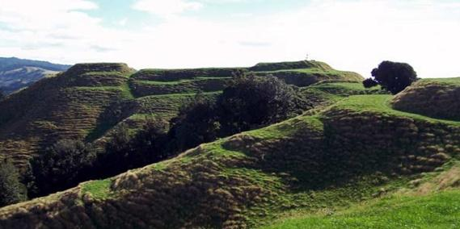 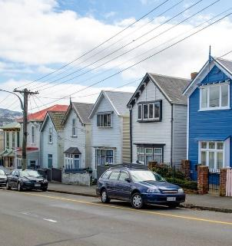 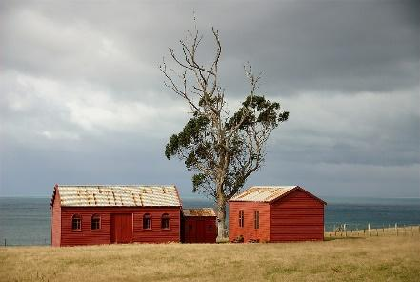

*Everyone’s Heritage:*

Celebrating the values of heritage in Aotearoa New Zealand

*ICOMOS Aotearoa New Zealand Conference 2024*

18 - 20 October 2024

Dunedin

**Everyone’s Heritage:**

**Celebrating the Values of Heritage in Aotearoa New Zealand**

Our heritage places, stories and landscapes help define us in the present and shape our future.

This year’s ICOMOS ANZ AGM Conference invites you to celebrate our heritage, through sharing stories of your experience - be they work, leisure or study, that reflect on ideas of our shared cultural heritage(s) and how the many values of heritage contribute to this. We consider that:

***Heritage has value****.*

“Value” means different things in different contexts. It may mean how we identify and assess our heritage; how heritage makes meanings for us; how heritage makes us feel through experiences; and the ways in which we place financial value on heritage.

It can mean the values that a heritage place can hold to different individuals and communities, and how we measure these values and promote them.

***Heritage creates a sense of identity.***

Heritage is about telling stories but it is also about the diversity of those stories. From the people who stepped off the first waka; the first European settlers to arrive; and even to recent emigres who have made their home in Aotearoa New Zealand, we have all brought cultural stories with us and have created new ones specific to this land. These stories often define us and have left tangible and intangible traces and places – all with different and fluid values.

***Heritage values are complex and layered.***

These layers may be cultural, physical, emotional, economic, political, environmental and social, amongst others. Our heritage places may be large and grand, small and humble, urban or rural, accessible or remote, or even under water. Some heritage places are owned or disowned, contested or loved, demolished or defended – all adding to the layered complexity of what we call heritage.

Our conference will share how we celebrate and negotiate our heritage through encouraging the exploration of concepts of “value” with its many meanings and implications.

**Sponsors**

ICOMOS Aotearoa New Zealand is deeply grateful to our sponsors:

**Dulux Heritage New Zealand Pouhere Taonga New Zealand Heritage Properties Origin Heritage**

 

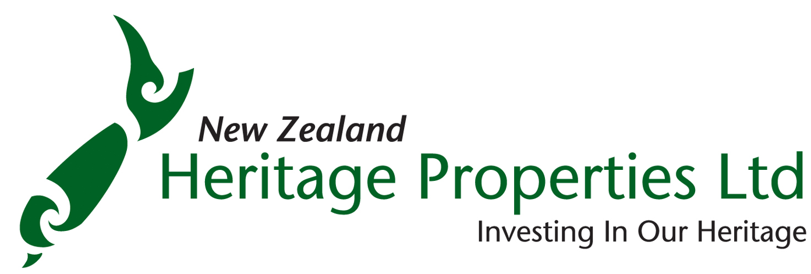 

**Conference overview**

**Venue:**

Toito Otago Settlers Museum, 31 Queens Gardens, Dunedin, CBD

|  |  |
| --- | --- |
| ***Friday 18 October*** | |
| 5.30-7.30 | Welcome drinks, Heritage New Zealand Pouhere Taonga offices, 210 Princes St |
| ***Saturday 19 October*** | |
| 9.00-9.30 | Coffee and registration |
| 9.30-9.40 | Welcome |
| 9.40-10.15 | Presentation from Hon Paul Goldsmith, Minister of Culture & Heritage |
| 10.15-11.00 | Morning tea |
| 11.00-12.30 | Papers |
| 12.30-1.30 | Lunch |
| 1.30-3.00 | Papers |
| 3.00-3.30 | Afternoon tea |
| 3.30-5.00 | Fieldtrips:  University or CBD |
| 7.30pm | Conference dinner |
| ***Sunday 20 October*** | |
| 9.00-9.30 | Welcome coffee |
| 9.30-10.00 | Presentation from Andrew Coleman, CEO, Heritage New Zealand Pouhere Taonga |
| 10.00-10.30 | Discussion of strategic plan |
| 10.30-11.00 | Morning tea |
| 11.00-11.30 | AGM |
| 11.30-12.10 | Papers |
| 12:15 | End of conference |
| 12.15-1.00 | Lunch |
| 1.00-3.00 | Fieldtrips:  prison/railway station or urban archaeology |

**Programme detail**

|  |  |
| --- | --- |
| **Friday 18 October** | |
| 5.30pm | Welcome drinks, Heritage New Zealand Pouhere Taonga offices, 201 Princes St  Generously hosted by Heritage New Zealand Pouhere Taonga; drinks and nibbles generously provided by New Zealand Heritage Properties |
|  |  |
| **Saturday 19 October** | |
| 9.00-9.30 | Welcome coffee and registration |
| 9.30-9.40 | Conference opening and Welcome |
| 9.40-10.15 | Presentation from Hon Paul Goldsmith, Minister of Culture & Heritage |
| 10.15-11.00 | Morning tea |
| ***Papers session 1:*** | |
| 11.00-11.20 | **If you can’t see it, you can’t be it: the importance of telling queer stories in heritage** |
| *Kerryn Pollock* |
| 11.20-11.40 | **Values of Heritage Digitalisation in Aotearoa New Zealand: Insights from Focus Groups** |
| *Renata Jadresin-Milic* |
| 11.40-12.00 | **Back from the brink: The rescue of 389 Princes Street** |
| *Hayden Cawte and Tony Purvis* |
| 12.00-12.20 | Quickfire presentations:  ★ Marcus Wainwright: Snapshot of Traditional Trades in and around Otago  ★ Susie Farminer: FindSomeone: Partner(s) wanted for developing Heritage Training! |
| 12.20-12.30 | Questions & discussion |
| 12.30-1.30 | Lunch |
| ***Papers session 2:*** | |
| 1.30-1.50 | **Introducing ICOMOS ANZ’s new website** |
| *Amanda Mulligan & Joanna Theodore* |
| 1.50-2.10 | **Recent Health and Safety Improvement Works on the 1880s Lyttelton Graving Dock, Lyttelton Port, 45 Godley Quay, Lyttelton** |
| *Patrick Harsveldt and Hannah Fyffe* |
| 2.10-2.30 | **Conservation plans in practice** |
| *Tim Holmes & Mike Gillies* |
| 2.30-2.50 | Quickfire presentations:  ★ Jeremy Moyle: Archaeology Defrosted: A summary of past and future work in the Ross Dependency, Antarctica  ★ Russell Cook: Central Otago’s Goldmining Landscapes and the Public Accessibility of History |
| 2.50-3.00 | Questions & discussion |
| 3.00-3.30 | Afternoon tea |
| 3.30-5.00 | **Fieldtrips:**  ***University***  A tour around the lovely campus of Otago University with Scarfie Flats author, Sarah Gallagher (also HNZPT Area manager) who has many interesting stories of the University to share on an interesting and fun talk and walk  ***Dunedin CBD***  The CBD tour will focus on several ongoing projects being managed by Origin Heritage |
| 7.30pm | Conference dinner:  Etrusco’s Restaurant, located in the Savoy Building at 8A Moray Place.  A welcome drink is generously sponsored by Origin Heritage |
|  |  |
| **Sunday 20 October** | |
| 9.00-9.30 | Welcome coffee |
| 9.30-10.00 | Presentation from Andrew Coleman, CEO, Heritage New Zealand Pouhere Taonga |
| 10.00-10.30 | Discussion of ICOMOS ANZ’s strategic plan |
| 10.30-11.00 | Morning tea |
| 11.00-11.30 | AGM |
| ***Papers Session 3:*** | |
| 11.30-12.10 | Quickfire presentations:  ★ Lucy King: The case for national direction on heritage: Examining approaches to heritage regulation in Otago  ★ Patrick Harsveldt and Alex Vakhrousheva: Professional Accreditation Opportunities for Heritage Professionals in New Zealand  ★ Carolyn Hill: “Does it have heritage value just for existing?” Young planners and emerging heritage futures  ★ Peter McKenzie: Issues for preserving and armouring heritage stained glass |
| 12.10-12.15 | Questions & discussion |
| 12:15 | Conference close |
| 12.15-1.00 | Lunch |
| 1.00-3.00 | **Fieldtrips:**  ***Dunedin Prison***  Led by Guy Williams who has spent many years leading the conservation and development of the prison (we regret we will not be doing the Railway Station as well)  ***Urban Archaeology***  The urban archaeology tour will take us to 386 Princes Street where NZ Heritage Properties have been working to preserve the remains of historic ovens, building recording and other archaeological work. Dr Naomi Woods will lead the tour (no PPE necessary; we note we will not be doing the hospital site) |

**Conference details**

**Costs**

The following are including in the conference registration

* All morning teas, afternoon teas, and lunches
* Friday night welcome function, sponsored by New Zealand Heritage Properties
* A welcome drink at the conference dinner, sponsored by Origin Heritage
* Fieldtrip choices

**Fieldtrips**

Two walking fieldtrips are offered each day:

***Saturday field trips***

* A walking tour around the university, enjoying its rich history and architecture
* A walk through the Dunedin CBD, focussing on recent development with commentary from practitioners involved in the projects

***Sunday field trips***

* A walking tour to the nearby Dunedin prison
* A walking tour to urban archaeological projects

*Note:*

* *Both Sunday field trip options are very close to the conference venue*
* *These Sunday field trips are deliberately after the conference end to give participants the chance to leave if necessary - it is noted that first afternoon flight to Auckland departs Dunedin at 1.15*

**Friday night welcome function**

We will have drinks and nibbles from 5:30pm to 7.30pm on Friday 18 October

Heritage New Zealand Pouhere Taonga office, Level 2, 201 Princes St, (entrance to the right of the Standard Kitchen cafe)

Generously hosted by Heritage New Zealand Pouhere Taonga; drinks and nibbles generously provided by New Zealand Heritage Properties

**Conference dinner**

7.30pm, Saturday 19 October

Etrusco’s, located in the Savoy Building at 8A Moray Place.

A fun and lively night is guaranteed! Singing is optional.

A welcome drink is generously sponsored by Origin Heritage

Etrusco’s has been in the same Italian family for over 30 years, and offers good food and an exuberant atmosphere.

**Map**

Blue star: conference venue, Toito Otago Settlers Museum, 31 Queens Gardens

Orange star: HNZPT offices, 201 Princes St (Friday night drinks)

Yellow Star: Etrusco Restaurant, Savoy Building at 8A Moray Place (Saturday conference dinner)

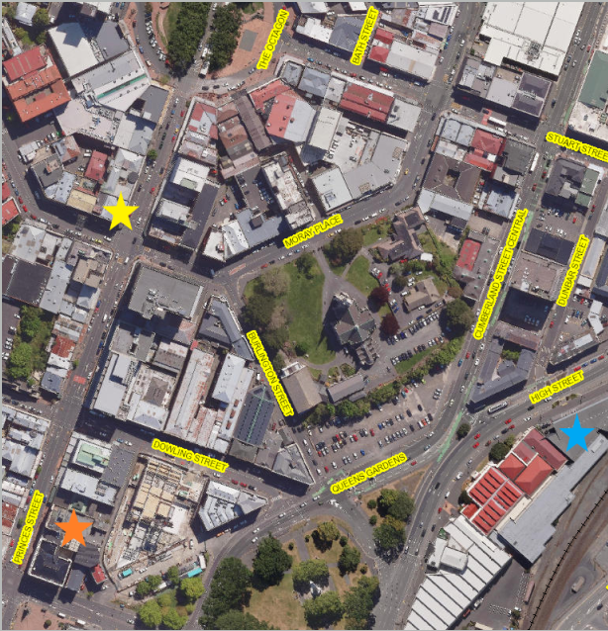

**Abstracts**

**Back from the brink: The rescue of 389 Princes Street.**

***Dr Hayden Cawte and Tony Purvis***

In late August of 2011, a devasting fire erupted in an unconsented apartment on the top floor of a book shop in Dunedin’s South Princes Heritage Precinct. The building at 389 Princes Street was seriously, and arguably irrevocably damaged in the fire. An insurance payout did see some protection installed by way of temporary roof, however, the building sat idle and deteriorating for six years before intervention saved it from likely demolition.

This paper highlights the process and experiences of salvaging heritage values in a ‘rescue’ context told through the stories of those involved.

**Central Otago’s Goldmining Landscapes and the Public Accessibility of History**

***Russell Cook***

Origin Heritage has been involved in the recording of a series of goldmining landscapes throughout the Central Otago region of Te Waipounamu, New Zealand’s South Island. This work has primarily been completed as part of archaeological requirements for the formation of new cycleways throughout the region. The creation of these cycleways has afforded us the opportunity to record a landscape that has remained largely inaccessible throughout much of recent history while also allowing members of the public to view these impressive human modified landscapes for the first time. While some track formation activities will have a minor impact on portions of the tailings, they balance the effects by providing access that would otherwise be impossible. While many would prefer to leave such landscapes wholly unaffected the question becomes at what point do, we limit or exclude the public’s access to history in the name of preservation.

**Looking Ahead: How we help develop the next generation of traditional building trades and skills**

***Dr Susie Farminer, Conservation Advisor/Kaitohutohu Penapena, Heritage New Zealand Pouhere Taonga***

A short ‘thinktank’ presentation on current and approaching traditional building trades challenges, positioning it as an opportunity to engage across our conservation profession to canvas for ideas, identify partners and potential resources, and how best to advocate for a long-term response.

**Conservation plans in practice**

***Mike Gillies and Tim Holmes***

Full building conservation plans drafted in accordance with James Semple Kerr’s ‘Conservation Plan' are too much for most clients who seek a cost-effective guide to assist them with urgent repair or renovation needs.

Where a conservation plan exists for a property, it is often found to be lacking in the detail required for practical work. This paper will present examples of projects where building owners need guidance that focuses on relative cultural heritage values of building fabric, in hand with a condition survey and practical advice to the treatment of each element of building fabric.

The structure of a typical conservation plan along the lines of Semple Kerr aims to be comprehensive, we will contrast this with an alternative pragmatic approach to addressing problems buildings present in practice and the need for succinct guidance, in relation to the assessment of Heritage value, diagnosis of building issues and appropriate treatment.

Building owners are looking for the most pragmatic use of resources, with as much as possible directed to the built solution.

So an alternative Conservation report approach, a pragmatic strategic assessment could target an issue at hand, with an inquisitive historical overview required to build a picture of significance, with greater inquiry into the area of greatest need, be it technical to solve a building defect or strategic to find a new use for example.

We are looking to develop a robust framework for clients seeking pragmatic solutions through a report that could be considered minimum standard and still be best practice to deliver outcomes the profession support.

Following a short presentation we would like to discuss and debate issues such an approach raises.

**Recent Health and Safety Improvement Works on the 1880s Lyttelton Graving Dock, Lyttelton Port,** **45 Godley Quay, Lyttelton.**

***Co-presented by Patrick Harsveldt (WSP Principal Heritage Consultant) and Hannah Fyffe (Lyttelton Port Company Senior Project Manager).***

Constructed between 1879 and 1882, the Lyttelton Graving Dock has been in continuous use as a port asset since it officially opened on 3rd January 1883. In its current condition as a working piece of wharf infrastructure, the Lyttelton Graving Dock has experienced relatively minor alterations over time

The Lyttelton Graving Dock is recognised as a heritage item by CCC in the Christchurch District Plan. The graving dock and pump house (foundations only, post EQ demolition) are listed with Heritage New Zealand Pouhere Taonga as a Category 1 Historic Place (List Number 4389).

This paper will present the recent site improvement work at the Lyttelton Graving Dock, Lyttelton. The project involved the installation of a fall protection system and three removable access stairs, which affected the historic stone and concrete fabric of this 1880s maritime structure. The recent health and safety improvement works will extend the life of the Lyttelton Graving Dock, and allow for its continued safe use as a working port’s asset.

**Professional Accreditation Opportunities for Heritage Professionals in New Zealand**

***Patrick Harsveldt and Alex Vakhrousheva – WSP Built Heritage Team.***

Members of the WSP Built Heritage Team have recently obtained (or applications are in process for) accreditations that no other heritage professionals in New Zealand currently hold. These include the *Certified Environmental Practitioner – Heritage Specialist* (*CEnvP - HER*) accreditation and the Heritage Accreditation from the Royal Institute of Chartered Surveyors (RICS). Information regarding the certification process, eligibility and work experience requirements will be presented.

**“Does it have heritage value just for existing?” Young planners and emerging heritage futures**

***Carolyn Hill, Lecturer, Environmental Planning, University of Waikato***

How could emerging views and values reshape statutory heritage-making in Aotearoa, in light of changing and increasingly contested urban environments? This talk provides a quickfire overview of my recent PhD research on this topic. I will briefly touch on three early questions in the enquiry, being: (1) how has the history of heritage-making in Aotearoa shaped its contemporary practice; (2) what insights do heritage protests provide into heritage processes in settler colonial cities; and (3) what is the current thinking of heritage policy leaders in the face of increasingly complex and competing demands on urban space. I will then talk to findings from mobile interviews with young emerging planners in the city of Kirikiriroa. I suggest that as an explicitly future-orientated profession, planning has a vital role in testing the purpose of heritage and the values it upholds within the politics of recognition, redress and urban equity.

**The case for national direction on heritage: Examining approaches to heritage regulation in Otago**

***Lucy King, Heritage Planner, Origin Heritage***

A national policy statement (NPS) is a planning tool that is available to state objectives and policies for matters of national importance. A NPS is employed where it would introduce significant nationwide benefits, costs, or values; provide significant benefits with a nationally consistent approach; or the issue involves technical complexity that makes it more efficient or effective to be addressed at a national level (Ministry for the Environment, 2021).

Examining heritage literature shows that many aspects of heritage conservation practice and management are contested. There is little agreement on defining what is worthy of protection to how built heritage should be protected. Internationally, approaches to heritage conservation are influenced by competing and co-existing discourses that drive different priorities and goals for built heritage (Ashworth, 2011). This is expressed at a local level, where there is a diverse range of approaches to regulating built heritage resources by Councils operating within the Otago region.

A NPS provides central government with the power to foster a more consistent approach and could address some of this variation by providing clear objectives and policies for built heritage resources. Under the current government, New Zealand's resource management system is undergoing change. Within this shifting landscape, New Zealand has the opportunity to place its heritage conservation at the forefront of international practice by positioning heritage conservation as central to development.

**Keeping intact heritage stained glass, along with the knowledge to conserve it, in contemporary Aotearoa**

***Peter McKenzie***

Aotearoa New Zealand heritage professionals have inherited a national collection of culturally significant stained glass work, much of which is at least 100 years old. This means that window stock is weakened and vulnerable from weathering. A notable proportion of those windows have unusually accelerated deterioration.

Can factors be identified that prematurely degrade leadlight armatures, leading to windows suffering damage and/or collapse? Can windows be protected safely and cost-effectively long-term, and sometimes stabilised short term, until funds are raised to attend them appropriately? Can resources be found to create the intergenerational building and transfer of knowledge to a cohort of stained glass professionals to look after this country’s stained glass heritage?

It may be timely to consider if heritage and educational institutions are capable and willing to drive such a programme.

**Values of Heritage Digitalisation in Aotearoa New Zealand: Insights from Focus Groups**

***Renata Jadresin Milic***

In the digital age, the preservation and celebration of heritage have taken on new dimensions. This paper will present the findings from three focus groups conducted as part of the ongoing research project, “Digitalisation of Heritage in New Zealand.” Building on our previous survey results published in the Architectural Science Review in 2024

(https://doi.org/10.1080/00038628.2024.2371057 ), this study delves deeper into the experiences and perspectives of various stakeholders involved in heritage preservation across Aotearoa New Zealand.

The three focus groups included participants from diverse backgrounds, including industry professionals, heritage practitioners, government representatives, community groups, and academics. Through these discussions, we explored how and how much digital tools and technologies are used to document, preserve, and share cultural heritage. Participants shared their experiences, highlighting the values, opportunities and challenges that digitalisation presents.

Key themes that emerged from the focus groups include: the democratisation of heritage through digital access; the role of technology in enhancing engagement with heritage sites; the importance of maintaining authenticity and integrity in digital representations. The findings underscore the multifaceted values of heritage in Aotearoa New Zealand, and the critical role that digitalisation plays in celebrating and preserving these values for future generations. The results gained from these focus groups also advise about several practical implications of digitalisation for heritage preservation in Aotearoa, New Zealand.

This paper aims to contribute to the ongoing dialogue on heritage preservation and conservation in the digital age, offering insights and recommendations for leveraging digital technologies to enhance the appreciation and understanding of our shared cultural heritage.

**Archaeology Defrosted: A summary of past and future work in the Ross Dependency, Antarctica**

***Jeremy Moyle***

Since the 1970s, there has been an intermittent programme of archaeological work carried out alongside the ongoing conservation of historic sites and monuments in the Ross Dependency, Antarctica. This presentation provides a quick overview of the work undertaken to date and plans for fieldwork during the upcoming 2024-2025 season.

**If you can’t see it, you can’t be it: the importance of telling queer stories in heritage**

***Kerryn Pollock, Area Manager and Senior Heritage Assessment Advisor in the Central Region Office of Heritage New Zealand Pouhere Taonga, and the lead of HNZPT’s Rainbow List Project.***

In 2023, a modest Edwardian building in Whanganui became to first place in Aotearoa New Zealand to be entered onto the New Zealand Heritage List/Rārangi Kōrero as a Category 1 historic place for the significance of its queer history. [Duigan’s Buildings](https://www.heritage.org.nz/list-details/1996/Duigan%E2%80%99s%20Buildings) in the historic city centre was the site of a key event in that history, the 1920 shooting of D’Arcy Cresswell by Whanganui major Charles Mackay, when the latter was blackmailed due to his homosexuality. What was more of an unknown was whether the building and its history had importance to contemporary queer communities. This paper explores the way heritage listing can draw out and record a place’s value to communities by providing an opportunity to voice and create connections, which in turn creates evidence for formal heritage assessment. More importantly, the Duigan’s Buildings listing experience demonstrates the contribution of heritage storytelling to identity and visibility.

**Snapshot of Traditional Trades in and around Otago**

***Marcus Wainwright***

Marcus Wainwright will discuss and showcase some highlights and challenges for traditional trades in Otago from over the past few years.