***“Tell me a story”***

**Interpreting Our Heritage**

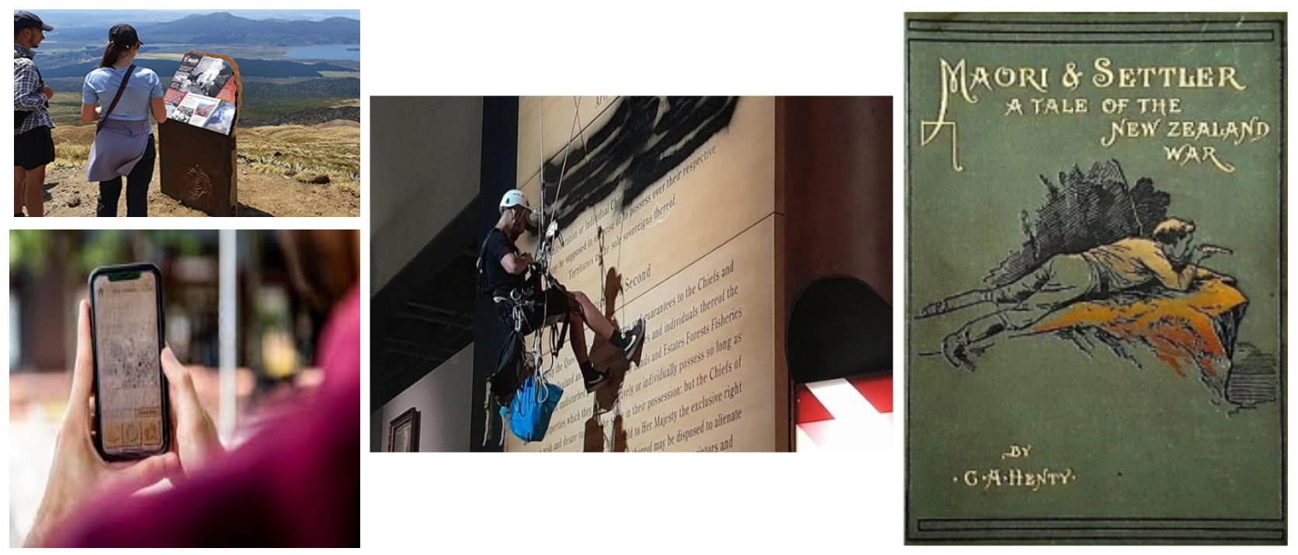

**ICOMOS Aotearoa New Zealand**

**& Historic Places Aotearoa**

**Joint Conference 2025**

**9 - 12 October**

**Napier**

**ICOMOS Aotearoa New Zealand Historic Places Aotearoa**

 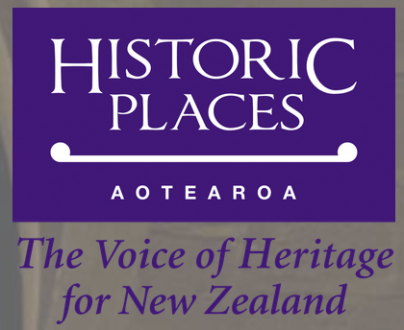

New Zealand’s rich cultural heritage and history has been packaged, presented and interpreted for over 100 years.

Much has changed in this time - the audience, the purpose, the technology and method.

What has driven these changes? Have the changes been successful?

Stories can be told orally and visually, through architecture and landscapes, through signage, technology, or integrated landscapes. It is often filtered through social context and historical context. Perceptions change over time: interpretation and storytelling from 50 years ago may now feel anachronistic, or culturally insensitive, or “cringe”.

We can reflect on particular ways in which our cultural heritage has been presented over time:

* Museums, from the 19th Century to now - the way in which they chose to display artefacts and objects, moving to more integrated storytelling
* The 1964 school bulletin “*Washday at the Pa*”: the Te Papa website notes “The *Washday at the Pa* controversy raised a number of important points, the principal one being whether Māori people had the right to say how they were depicted”.
* The Te Māori exhibition in the US in 1984
* Heritage New Zealand Pouhere Taonga’s digital walks and podcasts
* Movies, such as *Boy, The Piano, Once Were Warriors, Utu, Whale Ride*r
* Current methods of interpretation of sites and places, using signboards, digital apps, and other media

However important questions remain

* Who gets to tell the story?
* Who’s the audience?
* Who decides what the story should be?
* How does the storyteller know they’ve got it “right”?
* Who does the story belong to, so who has the right to tell it?

**Venue**

Our conference venue is the Heritage New Zealand Pouhere Taonga Category 1 listed Womens’ Rest building in Clive Square.

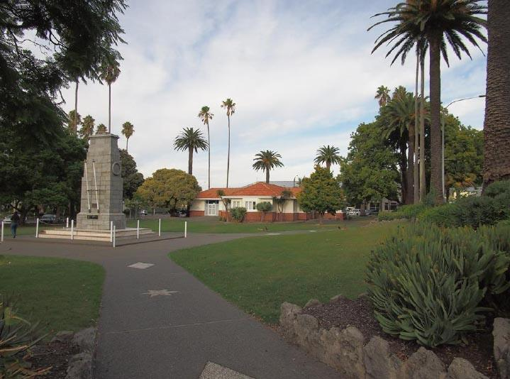

***Photo: New Zealand Heritage List/Rārangi Kōrero List entry***

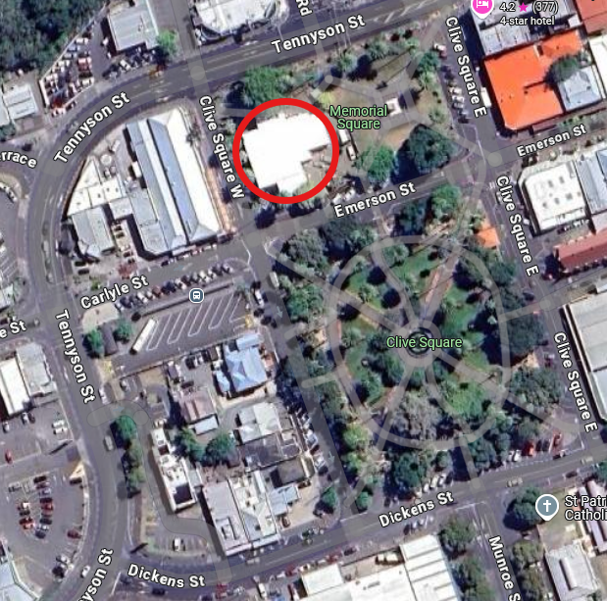

**Register for the conference**

**To book your space at the conference, please go to**

[**https://events.humanitix.com/https-icomos-org-nz**](https://events.humanitix.com/https-icomos-org-nz)

**Programme overview**

|  |  |
| --- | --- |
|  | ***Thursday 9 October*** |
| **1.00-5.00** | Field trips, leaving from Clive Square, Napier |
|  |  |
|  | ***Friday 10 October*** |
| **11.30-12.30** | Lunch and registration |
| **12.30-12.45** | Welcome from Organisations’ Chairs |
| **12.45-1.30** | Opening address |
| **1.30-2.15** | Papers |
| **2.15-2.45** | Afternoon tea |
| **2.45-4.00** | Papers |
| **5.00pm** | Drinks at Matisse, Herschell St |
|  |  |
|  | ***Saturday 11 October*** |
| **9.00-10.30** | Papers |
| **10.30-11.00** | Morning tea |
| **11.00-12.00** | Individual organisations’ session |
| **12.00-1.00** | Lunch |
| **1.00-2.00** | Papers |
| **2.00-2.30** | Afternoon tea |
| **2.30-5.00** | Walking field trips |
| **7.00pm** | Conference dinner – Portofino, Clive Square |
|  |  |
|  | ***Sunday 12 October*** |
| **9.00-9.45** | Presentation from Andrew Coleman, CEO of Heritage New Zealand Pouhere Taonga, and Dame Jo Brosnahan, Chirs of the Board of Heritage New Zealand Pouhere Taonga |
| **9.45-10.30** | Papers |
| **10.30-11.00** | Morning tea |
| **11.00-12.30** | AGMs |
| **12.30-1.00** | Lunch |
| **1.00-1.45** | Papers |
| **1.45-2.00** | Conference summary and close |
|  |  |

**Fieldtrips**

***Thursday field trips***

* You have a choice of three trips on Thursday
* Each trip will travel by bus, leaving from the Conference venue at Clive Square
* There is a cost of $25 per person for each trip
* Each trip is limited to 30 people
* **Ōtātara Pā**

Ōtātara Pā is one of the most outstanding pa complexes in New Zealand and has international significance. It comprises two pā sites: Ōtātara Pā and Hikurangi Pā. You will start at the car park and walk up the track past Ōtātara Pā to the top of Pā Hikurangi.

Ōtātara Pā has considerable archaeological significance as it is one of the earliest and most remarkable extant pa complexes in New Zealand. Ōtātara Pā stands apart from other pa complexes such as One Tree Hill and Te Koru because of its sheer size (44 hectares) and the complexity of its archaeological features, which have largely remained intact since the site's abandonment.

Ōtātara Pā is a place of tremendous cultural, traditional, and spiritual significance to Ngati Kahungunu iwi, particularly Ngati Paarau Hapu of Waiohiki who are kaitiaki for the site.

Your guides will be Taape Tareha O’Reilly and Chad Tareha, kaumatua from nearby Waiohiki Marae.

* **Hastings CBD Architecture**

Join Charles Ropitini on a walk-through the Russell Street and Queen Street Historic Areas of Hastings.  The walk will discover the Eclectic Revival and Stripped Classical architecture that frames a highly ornamented streetscape for those arriving by train from Wellington.  The Queen Street Historic Area will introduce you to some of Hastings’ surviving Edwardian buildings with a synchronicity of eclectic design.  The walk will end in Civic Square with the stories of Ngā Pou o Heretaunga.

Charles is the Pou Ahurea | Principal Advisor Relationships, Responsiveness & Heritage for Heretaunga Hastings District Council

* **Whare Ra, Havelock North**

This extraordinary building housed the New Zealand branch of the order of the *Stella Matutina*. It was designed and overseen by James Chapman-Taylor, a notable Arts and Crafts architect.

This building is not usually open to the public – we are very lucky to have an opportunity to visit.

*Note – no photography will be allowed during this visit*

***Saturday field trips***

* You have a choice of two walking field trips on Saturday – each are walkable from our conference venue
* There is a cost of $20 per person
* No limit on numbers for the Art Deco Walk
* The Matthews House visit is limited to 20 people
* **Art Deco Walk**

Your tour will start at the Art Deco Centre for a viewing of the 1931 Earthquake film where you will hear of the devastation of the city and the stories of the people it left behind.  Then you will embark on a 1-hour walk around the city centre with a professionally trained Art Deco Trust guide.

* **Matthews House**

This house was built in the mid-1860s. At the time it was the accommodation for the hotel that was in front of it. A noteworthy publican was George Henry Swan, who was a photographer, a brewer, a politician, and was mayor of Napier for a time.

The current owner has restored the house to look like a mid-19th century house, even to reproducing wallpaper. The furnishings also include military memorabilia, and furniture of the period.

**Social Programme**

***Friday night drinks***

We will meet for informal drinks on Friday night at 5pm. This will be at your own cost. The venue is Matisse, on Herschell St, opposite the MTG Hawkes Bay – the museum. Matisse is about a 10 minute walk from our conference venue.

***Conference dinner***

Our conference dinner will be held at Portofino’s Restaurant, located at 2 Clive Square – just across Clive Square from our conference venue.

All dietary options can be catered for.

Dinner is $70 pp

*You will be asked to choose your preference for your main meal at the conference dinner when you register for the conference, so the kitchen can plan ahead. Your choices are:*

**Pollo alla Cacciatora GF/DF**

* chicken breast grilled w. olive oil, garlic, chilli, capsicum, onion, olives, capers, parsley & pomodoro salsa, served w. mixed seasonal salad, toscana dressing & parmigiano

**Scaloppine al marsala GF**

* white veal prepared traditionally w. sweet marsala sauce, served w. mixed seasonal salad, toscana dressing & parmigiano

**Filetto al vino rosso GF/DF**

* grilled eye fillet w. olive oil, bacon, mushroom, garlic, vino roso crema sauce served w. mixed seasonal salad, toscana dressing & parmigiano

**Cannelloni ricotta e spinaci V**

* pasta cylinders filled w. ricotta, spinach & garlic, oven baked w. tomato, béchamel & mozzarella

**Risotto ai porcini V/GF/DF**

* porcini mushrooms, shallots, truffle oil, parmigiano & mixed leaves

**Gamberi Romani**

* prawn cutlets pan fried in e.v.o.o, garlic, flamed brandy, parsley, crema sauce, arborio rice & rocket